Introduction to Environmental Policy Comprehensive Exam

Throughout the weeks of study in this class you have been introduced to a variety of ways of thinking about environmental policy. In the early chapters you studied Steven Cohen’s Framework for Environmental Policy (see below) and evaluated that framework against the issues associated with the Rosemont Copper Mine.
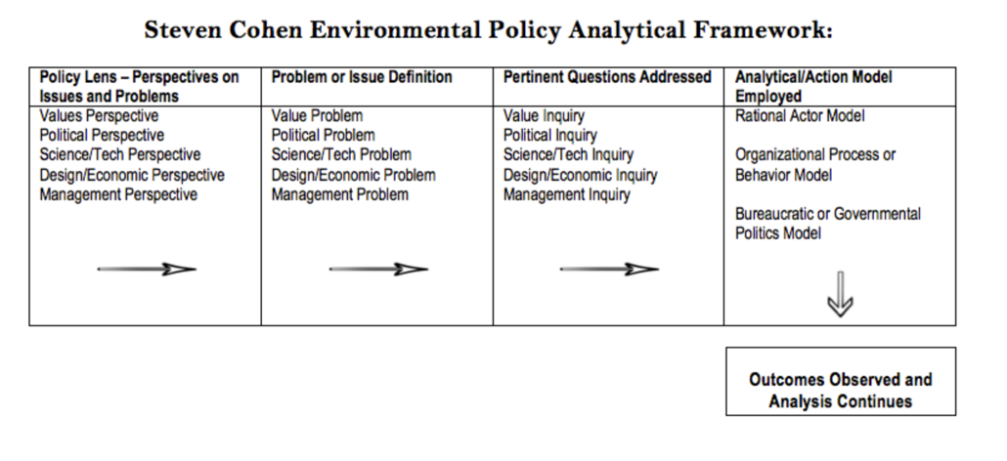
You were also introduced to the Framework for Ethical Decision Making from Santa Clara University which emphasized a common sense approach of recognizing when an ethical issue was at hand, followed by gathering pertinent facts, evaluating alternative responses, making a decision, testing outcomes, and acting and reflecting on outcomes.

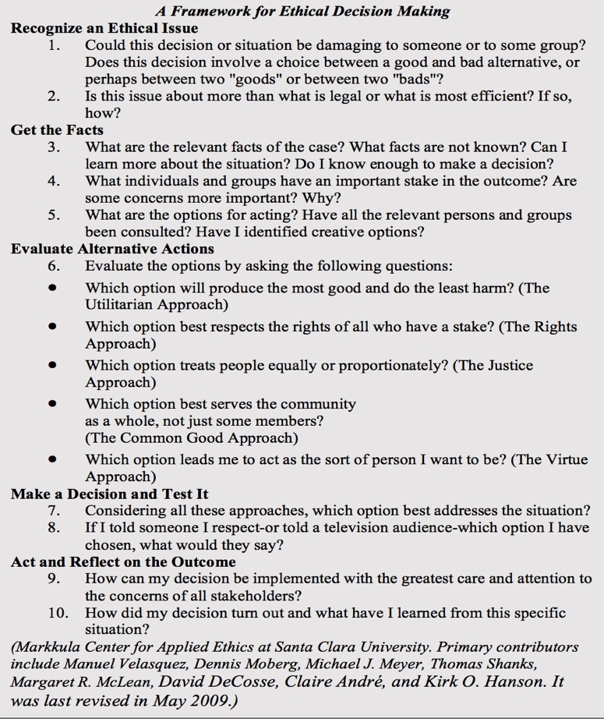
In Session 3 you were introduced to Florence Morestin’s Framework for Analyzing Public Policy followed by Ostrom’s Rational Choice Model

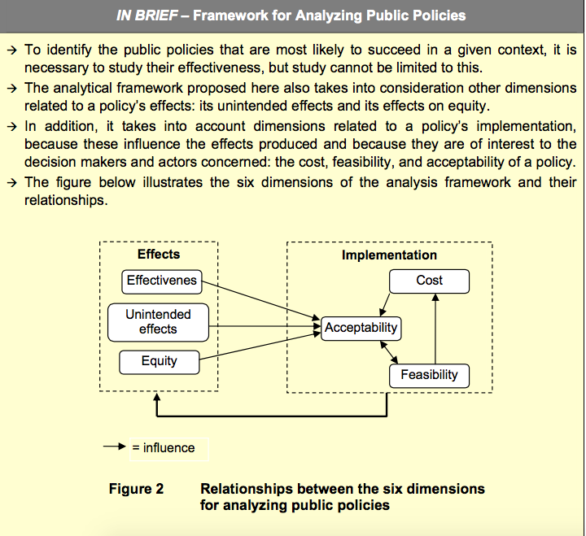

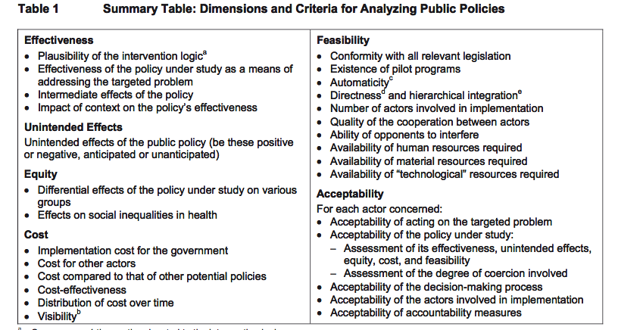
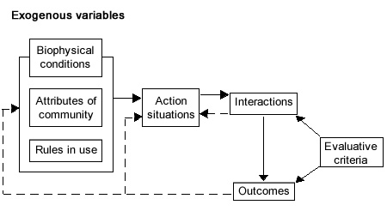

In Session 5 you were introduced to the Multiple Stream Approach

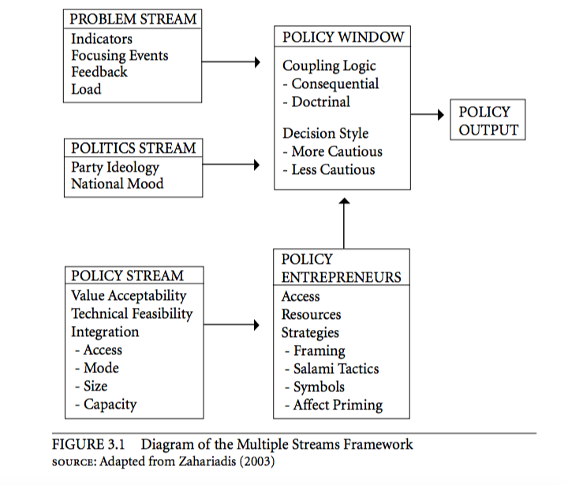

In Session 6 you studied Schneider and Ingram’s (1993) Target Population Model.

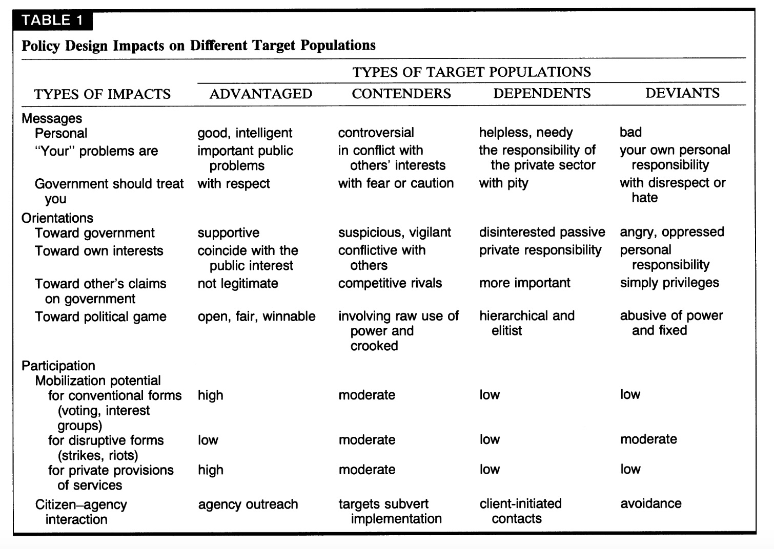

In summary, over this semester, these are the policy analysis models you have employed to look at a number of case studies. Your comprehensive exam follows on that pattern and asks you to consider a final case study. However, this time you will need to do a bit of research and explain specifically how each of the analytic models presented in this class could be applied to the problem of water toxicity from Lake Okeechobee.

Lake Okeechobee Water Pollution Exam

First read these reports and assessments regarding water quality issues associated with Lake Okeechobee:

- Facts About The Impacts From Lake Okeechobee Flows And The Need To Buy Eaa Lands To Divert Flow South

- Evidence Of Sewage-Driven Eutrophication And Harmful Algal Blooms In Florida's Indian River Lagoon

- The Lake Okeechobee Pollution Crisis And The St. Lucie River And Estuary

- Options for Reducing Harmful Lake Okeechobee Discharges and Everglades Restoration

- It’s Time to Set the Record Straight on the Lake Okeechobee Discharge

Then watch the following video material:

- Toxic Lake: The Untold Story of Lake Okeechobee

- Understanding Our Continual Harming Of The Everglades

- A River Film: Pollution in the St.Lucie Estuary

Now answer the following 10 exam questions on a separate piece of paper in which you first write down the question – immediately followed by your answer. All answers must be cited and referenced in APA style:

- Cohen talks about public policy in terms of value issues. Describe how Cohen’s analytical framework applies to the issues of water pollution associated with the management and ecological functioning of today’s Lake Okeechobee.
- Apply the Framework for Ethical Decision Making from the Markkula Center for Applied Ethics at Santa Clara University to the problem of Okeechobee water pollution.
- Thereafter apply Florence Morestin’s Framework for Analyzing Public Policy to the Okeechobee water pollution problem.
- Compare and contrast the Morestin and Markkula Center Frameworks as they relate to the Okeechobee water pollution problem.
- How does Morestin’s Dimensions and Criteria for analyzing public policy apply to the Okeechobee water pollution issue?
- How might Ostrom’s rational choice model be fruitfully applied to the Okeechobee problem.
- Ostrom asserts that: "Information search is costly, and the information-processing capabilities of human beings are limited. Individuals, therefore, often must make choices based on incomplete knowledge of all possible alternatives and their likely outcome.” How does this insight applay to the issue of water pollution in and around Lake Okeechobee?
- In the Multiple Stream Approach Zhariadis's asserts that policy options are built around 5 structural elements: problems, policies, politics, policy windows, and policy entrepreneurs. Specify how each of these structural elements apply to the water quality issues in and around Lake Okeechobee.
- Describe Schneider and Ingram’s Target Population Model as well as their social construction and policy design functions.
- Now, after having completed all of the other assigned questions for this comprehensive exam tell me which policy analytic model you like best and explain why this particular approach is best suited for analyzing the problem of Okeechobee water pollution.

